**GMAIL**

|  |  |  |
| --- | --- | --- |
| N | Student Name | Student number |
| 1 | Ali Al Qahtani | 437050824 |
| 2 | Asim Alharbi | 441051656 |

|  |  |
| --- | --- |
| Supervised by: | Ahmed Asiri |
| Year : | **2023-2022** |

**Introduction**

This project is a traditional typical software engineering work that contains famous common concepts of of describing and advertising a software to clients in a professional clear way we will see the software engineering fundamentals implemented on our sample app an email mobile application which is the “Gmail” app by using diagrams (activity diagram, use case diagrams, sequence diagram… etc.) that help us clear the vagueness and brake down the description of the application.

**Problem**:

Before the app people faced many problems, let us say human problems and software engineering-related problems. People before used to send mails via post-offices which included no videos or specific links that have a high degree of security, also people didn’t have the access to sending and receiving mails immediately with only putting their hands into their pockets and browsing mails or sending, deleting and editing them. these were some of the main problems that encouraged the creators of this app to decide to take the decision of making it.

|  |
| --- |
| **Background:**  “Gmail” is a mobile application made by google that support IOS devices and android devices. it was built based on the first model which is the website version. the app was introduced by google in 2006 but not with the same developed services that the app offers to users today.  **Proposed solution:**  The solution that the app proposed which would reduce the difficulties in the world of communications specifically mails (even though other apps might have used these ideas also) is first making reaching to and getting mails much easier and faster which makes it more flexible and fun not as complicated and difficult as before thus having easier life.  **Work Plan:**  We will start by defining the functional and non-functional requirements then show the diagrams respectively activity diagram, use case diagram, sequence diagram and finally class diagram. |

|  |  |
| --- | --- |
| Function requirement | Non-Function requirement |

|  |  |
| --- | --- |
| Click on the login button | The system must verify the registration data |
| Choose the type of account | Verify the use of the real owner |
| Log in using your email | Attachments should not exceed 25 MB |
| Log in using the password | Select 500 recipients or less when sending |
| Verify the login processes | - |
| Click on the Create button | - |
| Choose the future email address | - |
| Click send | - |

|  |
| --- |
| ***Activity diagram:*** |

***Cases Modelling:***

**Actros**: Gmail app transfer data to google server

(Gmail app, google server).

Uses case of Gmail are register user information, unregister user and delete user data, view data of user information, transfer information of users and contact users.

|  |  |
| --- | --- |
| Actros | Gmail application, Google server |
| Description | Gmail transfer data to server of google that maintained by Google, the data may update or retrieve the data. |
| Data | Users’ information |
| Stimulus | User command issued by Gmail application. |
| Response | Confirmation that google has been updated |
| Comments | The receptionist must have appropriate security permissions to access the user’s data and google server |

|  |  |
| --- | --- |
| Gmail | Register users |
| unregister users |
| View user info |
| Transfer data |
| Contact user |

**States and stimuli for the Gmail:**

|  |  |
| --- | --- |
| state | Description |
| Waiting | App waiting input from user |
| SetOperation | The application prepares the text Area for writing message |
| Disabled | App operation disabled for time sending (if long time with no use) |
| Enabled | App operation enabled when you logging in |
| Operation | The message(files) sending, app allow to you return the message after sending at short time (5 second) |

***Use Case Diagram:***

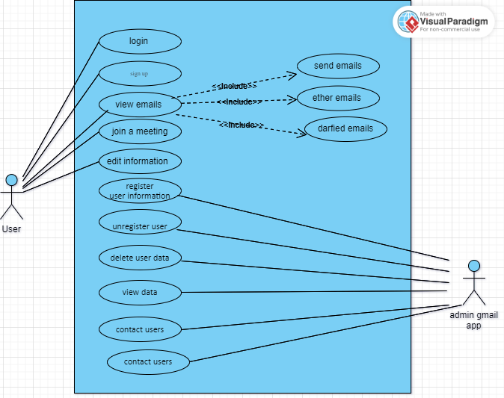

The drawing was designed through the virtual paradigm site

https://app.diagrams.net/

***Creating a Class Diagram(login):***

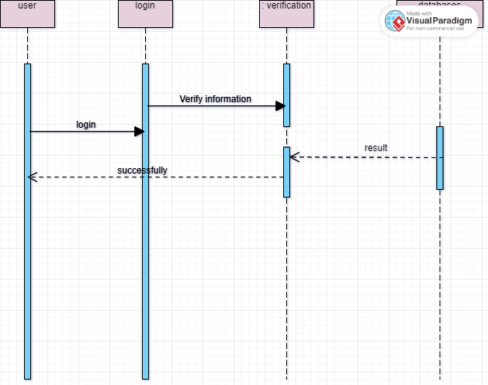

The drawing was designed through the virtual paradigm site

https://app.diagrams.net/

***Sequence Diagrams user:***

|  |
| --- |
|  |

The drawing was designed through the virtual paradigm site

https://app.diagrams.net/

***Creating a Class Diagram:***

|  |
| --- |
|  |

The drawing was designed through the virtual paradigm site

<https://app.diagrams.net/>

step 1,3 and 5 solutions by Asim.

Step 2,4 and 6 solutions by Ali.

All diagram are designed virtual paradigm site

<https://app.diagrams.net/>

**Thank you**